Politecnico di Milano

Scuola di Ingegneria Industriale e dell’Informazione

Corso di Laurea Magistrale in Ingegneria Informatica

Dipartimento di Elettronica, Informazione e Bioingegneria



Automated Analysis of Social Data using Machine Learning Techniques

Relatore: Prof.ssa Letizia TANCA

Correlatori: Prof.ssa Maristella MATERA Ing. Riccardo MEDANA

Tesi di laurea di:

Petar KORDA Matr. 852627

Pavle VIDANOVIC Matr. 854472

Academic Year 2017–2018

*We would like to express our sincere appreciation to our supervisors and our families for all their support. We would also like to extend a special thank you to Prof.ssa Maristella Matera for her time, guidance and understanding.*

**Abstract**

With the rise of social media the way business and customers interact has drastically changed. Business are expected to have a web presence and to produce content in order to engage with their user base on a daily base. In return, the users don’t shy away from leaving feedback, and they leave a lot of it.

Having that in mind, it is easy to see how having an automated way to tell if the user-generated content was negative or positive would provide a lot of value for a businesses. Coincidentally, in recent years a lot of research and advances have been made in the field of sentiment analysis and the efforts yielded a number of tools for predicting sentiment of textual content. This is why we were interested in examining the landscape of open source APIs that provide that functionality.

In this thesis we have built a framework for assessing the performance of some open source APIs for sentiment analysis. The APIs were tested against a dataset of social media content generated by real fashion brands and their user base. Because of the global nature of the fashion industry the APIs were appraised on how well they perform in predicting sentiment of data in original language as well as their English translations. Finally, the framework improved the accuracy of procured sentiment predictions by taking into account the sentimental value of emojis and emoticons found in the data.

**Sommario**

Con l’avvento dei social media, il modo in cui le aziende interagiscono con i propri clienti `e drasticamente cambiato. Da un lato, le aziende devono necessariamente avere una presenza sul Web e produrre contenuti su base giornaliera in grado di coinvolgere i propri clienti e attrarne di nuovi. Dall’altro i clienti non hanno timore a rilasciare numerosi commenti sul Web e soprattutto nei social media.

In questo scenario, `e semplice intravedere del valore aggiunto per le aziende nei metodi automatici in grado di individuare se i contenuti generati dagli utenti hanno un’attitudine negativa o positiva. Infatti negli ultimi anni molte attivit`a di ricerca sono state dedicate alla analisi del ”sentiment” e hanno portato alla definizione di diversi strumenti automatici per predire il sentiment dei contenuti testuali rilasciati dagli utenti nel Web. Questo scenario ci ha spinto a esaminare con il nostro lavoro di tesi alcune API open source per la sentiment analysis. In particolare, la tesi riguarda la costruzione di un tool per valutare e confrontare API diverse.

Il tool sviluppato ha permesso di applicare le API su un data set di commenti generati da aziende che realmente operano nel settore della moda e da utenti di social media (Facebook, Twitter) che fanno parte della fan base delle aziende. Vista la natura globale dell’industria della moda, le API sono state applicate sia ai post nel loro linguaggio originale, sia alla loro traduzione in Inglese. Infine, tramite il framework definito, abbiamo provato come l’accuratezza dell’analisi del sentiment possa migliorare se si tiene conto del significato degli emojis e degli emoticons presenti nei contenuti analizzati.

**Contents**

1. **Introduction 1**
   1. Structure . . . . . . . . . . . . . . . . . . . . . . . . . . . . . . . . . 1
2. **State of the art 3**
   1. Need for sentiment analysis . . . . . . . . . . . . . . . . . . . . . . . 3
   2. Application of sentiment analysis in various companies and non-profit

organizations . . . . . . . . . . . . . . . . . . . . . . . . . . . . . . . 4

* 1. Some tools for sentiment analysis . . . . . . . . . . . . . . . . . . . . 5

1. **Sentiment analysis workflow 9**
   1. Sentiment prediction workflow . . . . . . . . . . . . . . . . . . . . . 10
   2. Determining real sentiment workflow . . . . . . . . . . . . . . . . . . 14
   3. Evaluation workflow . . . . . . . . . . . . . . . . . . . . . . . . . . . 14
2. **Framework 15**
   1. Design . . . . . . . . . . . . . . . . . . . . . . . . . . . . . . . . . . . 15
   2. Implementation . . . . . . . . . . . . . . . . . . . . . . . . . . . . . . 16
      1. Database overview . . . . . . . . . . . . . . . . . . . . . . . . 16
      2. Sentiment analysis APIs . . . . . . . . . . . . . . . . . . . . . 23
      3. Sentiment analysis scripts . . . . . . . . . . . . . . . . . . . . 26
      4. Web server . . . . . . . . . . . . . . . . . . . . . . . . . . . . 30
   3. User interface . . . . . . . . . . . . . . . . . . . . . . . . . . . . . . . 32
      1. Web Application UI . . . . . . . . . . . . . . . . . . . . . . . 32
      2. JSON REST API UI . . . . . . . . . . . . . . . . . . . . . . . 35
3. **Results of APIs comparison 37**
   1. Experimental setting . . . . . . . . . . . . . . . . . . . . . . . . . . . 37
   2. Results and discussion . . . . . . . . . . . . . . . . . . . . . . . . . . 39
4. **Conclusion 45**
   1. Connecting to mining approaches – Applying clustering in sentiment

analysis . . . . . . . . . . . . . . . . . . . . . . . . . . . . . . . . . . 46

i

*Contents*

6.2 Spam detection 47

6.3 Out of the black box – Training a model 48

Bibliography 50

List of figures 51

List of tables 53

**Chapter 1**

**Introduction**

Sentiment analysis is the process of computationally identifying and categorizing opinions expressed in a piece of text, especially in order to determine whether the writer’s attitude towards a particular topic, product, etc. is positive, negative, or neutral [Oxford dictionary definition]. How could we in future depend on it? With growth of applying marketing through social media gives us opportunity to seize information about products spread around the media. By analyzing customer’s input about a certain campaign, product or brand’s strategy a company could predict future trends, decrease costs and increase profit.

Within the described context, this project aims to give statistical comparison of open source APIs used to determine sentiment on small dataset consisting of social media posts and related comments in the field of fashion. Given the increasing number of Sentiment Analysis APIs available online, our framework is meant to help developers of new applications, which need to leverage on sentiment services, to compare different resources and choose the one(s) that best fits the application requirements. Four different API endpoints were chosen to be compared on the grounds of them being free, openly available and easily programmatically accessible. However, given its extensibility, the framework can be a useful mean for the comparison in general of sentiment analysis resources – not only the ones that we exploited in the experimental part of our work.

### 1.1 Structure

* In chapter 2 we will present the reasons for doing sentiment analysis within a company or a non-profit organization, today’s successful solutions and their consequences. We will mention about some of the used commercial solutions, their strengths and weaknesses. Afterwards we will list some open source libraries.
* Chapter 3 is dedicated to describing the workflow of our project by illustrating

*1. Introduction*

all the steps of the process from collecting the data, analyzing it with different APIs, determining real sentiment, and finally calculating the APIs accuracy.

* In chapter 4 we will give an overview of the Framework we have built with all its components. We describe the high level architecture of the system and go down to explaining the role of each component. We will finish the chapter by giving a sketch of the user interface.
* Chapter 5 is the part where the project results are supported with interpretations. We will present all the statistical results we have obtained after comparing different APIs.
* Chapter 6 will finalize the purpose of the project and conclude our findings. Also we will mention about future improvements such as doing clustering in sentiment analysis, finding a better spam detection solution and eventually training a model that would accommodate our domain problem.

**Chapter 2**

**State of the art**

This chapter describes state of the art of sentiment analysis in social media. Chapter consists of three sections, each of them trying to bring closer the need for sentiment analysis in current market:

1. Need for sentiment analysis
2. Application of sentiment analysis in various companies and non-profit organizations
3. Some tools for sentiment analysis

### 2.1 Need for sentiment analysis

With growth of people’s interaction and company’s advertisements through social media, we have come to the point of realizing that people sharing opinions could help us ”predict” stock market and as well follow current trends by guiding the market according to the customers input. Customers nowadays have endless ways to interact with brands which could help increasing brand’s awareness, but if not properly analyzed could also lead to obtaining not quite accurate view of customer’s satisfaction. The idea of analyzing customer opinion has driven companies to search for an automated way of understanding content that are customers sharing online. The main network for spreading opinions is social media. Almost every tweet, comment, re-share or review gives an information that could guide a company towards better planning, optimizing production and better stock managing. Reason for finding an automated way of analyzing customer’s opinion comes from a problem of big data being generated each day which makes impractical to do manually analysis of each user input. Leaving the big data problem aside, brings us to another issue; being able to beat natural language processing challenge. Reason for making the task harder is that user input might be informal, ”slang like” content with emojis

, hashtags, full with sarcastic sentences which would lead to unreliable results of analysis.

### 2.2 Application of sentiment analysis in various companies and non-profit organizations

Customers engagement through social media can be a valuable asset for companies to understand level of acceptability of their products. By finding a way to analyze raw text data and catch the key context from it could potentially result in decrease of stock planning cost and in increase of profit. Over the years many companies and nonprofit organizations have started applying some kind of data analysis for this purpose. One of current expanding areas of data analysis is the sentiment analysis, this emerging technique has been applied in various spheres. We will give an insight to few representive examples of successful solutions and their consequences. Cathay Pacific as one of leading airline companies started using one of the commercial solutions for sentiment analysis. They have used Brandwatch platform in order to monitor how their campaign hashtag has been mentioned across social media. Specifically, in which connotation the hashtag has been used, what people talk about when putting it in their posts, which has been show in Cathay Pacific Case Study: Using Social Data to Inform a Global Business [1] Aside the sentiment sensing, they are using the platform to identify trends, such as what are people talking about when traveling and where are they traveling to. This kind of data can help them create new ideas for future developments. Nonprofit organizations like American Cancer Society are using sentiment analysis in order to obtain feedback on organized fund raising event. The difference between this kind of sentiment analysis and the one used by Cathay Pacific is that for ACS a model needs to be trained because words used have another connotation for them. For example, words such as “kill” and “cancer” in case of ACM should have positive sentiment. Sensing on social media has shown that ACM had spikes in user engagement every time there was a big fund-raising event. In order to raise more funds, by data analysis they have realized that doing more announcements before, during and after the event could help them to raise people’s awareness about the problem they are fighting against. The ACS also used sentiment analysis to find out what it should be tweeting and posting. For instance, October is Breast Cancer Awareness month and pink ribbons are everywhere. Some NFL teams even wore pink shoes and gloves to raise awareness cited in How Starbucks And Other Companies Use Complex Math Algorithms To Read Your Feelings Online[2].

*2.3. Some tools for sentiment analysis*

### 2.3 Some tools for sentiment analysis

#### Commercial solutions

As every commercial product, basic goal is user satisfaction. Commercial solutions provide user with rich customizable, easy to use interfaces for a not so fair price. By paying for the service users, usually medium to large scale companies, receive a platform which contains algorithms for data analysis used as a black box and detailed colorful visualization tools for representing results of the analysis. One of important issues that users wouldn’t deal with, as they would if building their own solutions, is that such platforms usually come with needed infrastructure to support such data intense analysis. Here we will mention few most widely used commercial tools.

*Google Analytics*

Google Analytics helps you know your audience, find your best content, and optimize ad inventory. Providing you with real-time reports of what is happening on your site right now so you can make adjustments fast. Engagement metrics help you see what is working, while integrations with Google and publisher tools like AdSense, DoubleClick AdExchange, and DoubleClick for Publishers (Analytics 360 only) make it easy to package and sell your ad inventory. Google has developed a solution which enables the user to gather data, preprocess it, and train a model using Google Prediction API like a black box.

*Sales Force Marketing Cloud solution - Radian6*

Most certainly that human sentiment analysis is the most accurate method even if you think how much human differ in their interpretation. Radian6 has introduced an automated sentiment analysis tool which has flexibility to allow users to change the perspective of analysis. If you do real sentiment evaluation manually, you will obtain more accurate results than any other automated tool could give you. Given a simple example, if a user compares different beverage brands, most likely he would rate better the beverage he prefers based on the prevailing taste of it. Radian6 solution will enable the user to do deeper analysis into specific topics via different types of ad hoc analysis Radian6 has given various solutions to fill the gap between marketing and customer satisfaction by using social insights to drive marketing campaigns. By listening, engaging and analyzing data on social media, users are able to create sales plans which could lead to better stock planning.

*Brandwatch*

Brandwatch Analytics is a web-based platform with monthly subscription basis with different range of packages meeting needs of various company sizes. They search and store date based on users queries on the market. Quite accurately guarantees spam free and duplicate free data. With the gathered data they assure you of optimizing marketing in social media. The platform offers various customizations that could accommodate to the needs of the user. By acquiring data every day and providing users with tools to analyze and visualize them, they have convinced a lot of famous brands that Brandwatch is a good tool to help them make data-driven market decisions such as Cisco, British Airways and Dell. Good thing about Brandwatch as a commercial solution is that it provides coverage of various data sources, independent of language barrier or data quality. Besides of the coverage advantage, it provides stable analytic tools, as well as visualization tools. It is mostly used by large companies that could afford the platform.

#### Open source solutions

Main benefits of adopting an open source solution are lower costs, in this case using an open source library is free, as well as trend of keeping an open source solution always available because it is usually maintained by a community. For a commercial solution, it could happen that a vendor shuts down his business and with it taking its software out of market. Another major advantages of using an open source solution is that often there is a collaboration between libraries and as well as variety of available solutions. Open source solutions are not bind to changes and updates to releases; instead they can be developed collaboratively when functionality is needed. Of course using an open source library can have its down sides, a library or an API call can be limited by number of usages by day or by accepted amount of data it can receive. Thus implicates that these kind of solutions are not setting up an infrastructure that could handle data-intensive analysis and are usually used for educational purposes.

*Natural Language Toolkit*

Natural Language Toolkit is an open source platform for building programs which work with textual data. It is equipped with various libraries for text processing which provide tokenization, tagging, stemming and handy wrappers around NLP libraries. NLTK has a very detailed documentation which can guide a developer in building an application that suits his needs. Highly recommended for people that feel free working in Python.

*Stanford’s CoreNLP*

Provide set of tools written in Java for purpose of natural language processing. Initially was built to work only with English language, but latest releases support languages such as Arabic, Chinese, French, German and Spanish. It is an integrated framework easy to use for language manipulation on raw inputted text. The result it gives after initial analysis is a good starting point for building application with domain-specific problems. Besides low level natural language processing, it contains as well some traces of deep learning algorithms.

*Text-Processing*

*2.3. Some tools for sentiment analysis*

The text-processing is an open source API which returns simple JSON over HTTP web service for text mining and natural language processing. It is an API which supports speech tagging, chunking, sentiment analysis, phrase extraction and named entity recognition. As an open source solution it has its limitations, such as 1000 calls per day per IP. To get the sentiment of a text, users should do an HTTP request with form encoded data containing text to analyze. As a response, users will receive a JSON object with a label marking the sentiment (can be pos as positive, neg as negative or neutral) and a probability for each label.

Searching around Internet about sentiment analysis has shown us that each of the available solutions has it’s strengths and weaknesses. Seeing that APIs behave differently depending on the data or domain applied on, we came to an idea to build a framework that gives an overview of the open source APIs, concluding their advantages and disadvantages, as well as representing comparison between them. Building a framework that is able to invoke different APIs and show sentiment results with statistical representation of accuracy has been a good indicator of choosing an appropriate solution for a specific problem domain.

**Chapter 3**

**Sentiment analysis workflow**

This chapter describes the workflow used to analyze the sentiment of social media comments and their corresponding posts. In order to outline the workflow, a top down approach was taken where each subsequent section provides an ever more detailed insight into a particular step of the workflow. The big picture is shown in Figure 3.1 and consists of four parts:

1. Obtaining data
2. Sentiment prediction using an API
3. Determining real sentiment of data
4. Evaluation of that API’s performance

The first part is the simplest one and as such doesn’t merit a more detailed recounting other than mentioning that we were provided with a small sample dataset which, most relevantly, contained about 6000 comments.

In the sections that follow, each of the three remaining parts are broken down into conceptual steps describing the methodology used whilst not cluttering it with too many implementation details. Additionally, it is interesting to note that the first and third steps are performed only once. This means that, for each new API we want to use, the workflow for sentiment analysis effectively consists of only steps 2 and 4, namely sentiment prediction and performance evaluation.



Obtaindata



Predict

sentiment



Determine

realsentiment



Evaluate

predictions

Figure 3.1: Sentiment analysis workflow

### 3.1 Sentiment prediction workflow

Let’s assume we have access to an API for sentiment prediction. By having access we mean being able to programmatically call the API with a text payload and have it return a prediction in some data format. The end goal is to analyze sentiment of all the comments in our sample dataset and aggregate the obtained data on a per-post basis in order to infer whether it was positively or negatively received, or even if it had no emotional impact whatsoever. And we want this to be done automatically, practically with a push of a proverbial button. By automatizing the process, it is easy to see how it can derive value for possible future ventures that extend far beyond our modest 6000 comment database.



Findnew

comments



Translate

comments



Predict

sentiment



Adjust

prediction

toaccount

foremojis



Aggre-

gateposts’

sentiment



Start



End

Figure 3.2: Sentiment prediction workflow

Figure 3.2 shows the main concepts that build up the workflow of our sentiment analysis. Since the term *workflow* can be a bit ambiguous, let us clarify exactly what we mean by it. In our case it is simply a python script named *automated*

*3.1. Sentiment prediction workflow*

*sentiment analysis.py* that can be run manually, or scheduled to run on a server at desired times/intervals. Sections that follow will explain each step in more detail and will also provide motivation for some, perhaps not so obvious, choices.

#### Find new comments

This part is quite straight forward. Once run, the script scans the database looking for comments that don’t have a sentiment record attached to it and inserts one. The inserted rows’ sentiment columns default to a json shown in Listing 3.1. The reason for this particular choice of json and for using the json format in the first place is discussed at length in Section 4.1. Also, notice the use of the plural formsentiment columns. This way we are able to store sentiment predictions from each API we planned on using in their own columns.

{

"sentiment_label": "",

"sentiment_stats": {

"positive": 0,

"negative": 0

"neutral" : 0

}

}

Listing 3.1: Default sentiment json

#### Translate comments

To reiterate, our dataset consists of real comments to posts published by actual fashion brands. Since fashion truly is a global industry, the posted comments are in a myriad of different languages. In our case the number of different languages is somewhere above of 70. This provided us with a challenge because most sentiment analysis related APIs handle (well) only content written in English. And the very few that offer support for other languages do so just for a handful of them. This is especially true for the open source variety of APIs that were used for the purposes of this thesis.

Even thought the rationale for using comments’ English translations seems to hold, we wanted numbers to back up our claims. In other words, we wanted to quantify just how much worse the APIs would perform if we fed them comments in their original language as opposed to English. So for two out of four APIs used, we analyzed both, the content in original language and the English language. The results are examined in Chapter 5, but in short, they are in accordance to what we expected.

This brings us to another caveat. We’ve just coupled the quality of sentiment predictions with the quality of the translations. After all, the prediction can only be as good as the translation. Since we were trying to evaluate performance across multiple open source APIs, we wanted the best translations possible to try to mitigate this problem. Hence we opted for what we felt was the current industry standard, Google’s Translate API[1]. It is worth noting that this is the only step we hadn’t taken the open source option but used a free trial period instead to do a one-off translation of our entire dataset.

#### Predict sentiment

For each unanalyzed comment a we call a specific API requesting a sentiment prediction of the comment’s translated content[2]. If no API is specified the script sequentially makes requests to all defined. Since each API’s response is in a slightly different format, the response is parsed to adhere to the json definition shown in Listing 3.1. After which, the API’s sentiment column for that particular comment is updated with the received (and parsed) values.

#### Adjust prediction to account for emojis

In this day and age everybody uses emojis and emoticons, and a lot of it. To disambiguate the two terms, here are the definitions offered by the Oxford dictionary:

**emoji** / I"m@UdZi / *origin* (1990s) Japanese, from e=picture + moji=letter, character *noun* a small digital image or icon used to express an idea or emotion **emoticon** / I"m@UtIk6n / *origin* (1990s) blend of words emotion + icon *noun* a representation of a facial expression such as a smile or frown, formed by various combinations of keyboard characters and used to convey the writer’s feelings or intended tone

To put it simpler, the difference is between symbols  and *<*3. The former being an emoji and the latter being an emoticon. But we digress, the point was to emphasize the very emotional nature and motivation behind using these symbols in a text, comment or post. Having an emoji or an emoticon mixed with text can drastically change our perception of the sentiment behind it. Take these three simple comments:

*3.1. Sentiment prediction workflow*

I read that book

I read that book <3 I read that book 

Unless we happen to know the person that wrote the the first comment, its content in plain text doesn’t really codify enough information for us to make a judgment call weather or not this person liked or disliked that book. On the other hand, the other two comments are quite unambiguously positive. That one little symbol made all the difference in how we perceive the text that preceded it. Unfortunately, all APIs that we tested would ignore these descriptive symbols, so we decided to write up a very simple algorithm based on the *Emoji Sentiment Ranking*[3] which came to be as a part of the Sentiment of emojis study[3]. The algorithm will be described in more detail in Section 4.2. But in short, the algorithm tweaks the sentiment of comments which contain emojis or emoticons. Then it stores the recalculated result in a separate database table so it doesn’t clobber the original data. This allows us to both fine tune our algorithm and to compare the predictions that took the sentimental value of emojis into account to those that didn’t.

#### Aggregate posts’ sentiment

Everything leading up to and including this point was done automatically by running the *automated sentiment analysis.py* script. Finally, all that is left for the script to do is to aggregate the sentiment data for each post. This boils down to counting how many sentimentally negative, neutral or positive comments does a post have. The results of this data aggregation are stored in a json format as shown in Listing 3.2. Perhaps the most informative field there is the *sentiment label*. It is essentially one API’s appraisal of how well (or badly) had the public received a published post. Of course, this aggregation is done for each post and API separately. So, for example, according to one API a post might have been overall positively received, while data coming from another API might yield a different conclusion. Sections 3.2 and 3.3lay out workflows for assessing API’s reliability.

{

"sentiment_label": "positive",

"sentiment_stats": {

"positive": 38,

"negative": 2,

"neutral": 9,

"total": 49

} }

Listing 3.2: Example of a post sentiment json

### 3.2 Determining real sentiment workflow

In order to answer the question weather or not the obtained sentiment predictions are any good and to determine if any one API outperforms all others- we need sentiment data that we hold true and we need it for each comment. That way we have a real (true) sentiment record to compare against. Since the only state of the art sentiment analyzing machines at our disposal were the two humans writing this thesis, we decided to read all the comments one by one and input our sentiment predictions by hand. Thus, from this point on, when ever we refer to *real sentiment* we mean our own judgment of the sentiment behind the comment. To make this manual process a bit easier for ourselves, we’ve made it possible to input or modify sentiment for each comment in multiple ways. It can by done via the command line, e.g by doing a curl call to the framework’s REST API or via its the graphical user interface. But easiest and most efficient way is to run the *update real sentiment.py* script. The script allows you to specify a range of comments which you want to analyze using command line arguments. The script then sequentially fetches specified comments, prints out their ids, content and English translations and asks for 3 pieces of information as shown in Figure 3.3. It requests a sentiment prediction to be input, weather or not one assesses this comment to be spam and if there was a mention of another user in the comment in question. We were interested to have the two last pieces of intelligence mainly out of curiosity to see how API’s would have performed if the dataset was clean from these types of comments, however, they are also a good basis for future extensions of our work.



Determine

realsentiment



Determine

ifspam



Determine

ifmention

Figure 3.3: Determine real sentiment workflow

### 3.3 Evaluation workflow

Now that we have the real sentiment of each comment as well as sentiment predictions, we can evaluate the performance of each individual API. Running the *evaluate api performance.py* will calculate accuracy, precision and recall for each API unless a specific one is specified as an argument.

**Chapter 4**

### Framework

#### 4.1 Design

The most prevalent web development paradigm in the recent years has to be designing software components as APIs. The term API is short for Application Programming Interface and is essentially an interface to retrieve and manipulate data. But unlike a graphical user interface (from now on GUI) whose end users are people, API’s users are other applications. Having a single point of entry which abstracts and manages resources in a consistent manner provides lot of benefits in terms of maintainability, automation and future development.

That is why we took the API-first approach when structuring our sentiment analysis framework. The idea was to build a RESTful API on top of the provided sample database and use it for multiple purposes, namely, a web app, API’s GUI or any scripts and third party applications that might need to access database records. However, during one development iteration the requirements somewhat changed. It became clear that the collection of scripts used for sentiment analysis (see Section 3.1) would provide more value if their data requests didn’t go through an API but by making calls directly to the database. Even though this decision might seem to counter all previously listed benefits, it was important to realize that our efforts weren’t an independent endeavor but a possible extension of our university’s existing framework for managing social media accounts. Considering the redefined context in which we were developing, it made sense to design the collection of server-side scripts so that they depend only on the specifics of the provided database schema. This way, should our attempts yield satisfactory results, the collection of scripts could easily be deployed and reused in the university’s existing framework. Our goal then became twofold, first designing an API-independent script bundle and second designing an API-dependent web application and its GUI. The purpose of the two latter services was mainly to aid development and to have results presented in an intuitive manner.

Finally, a high level design of the system is shown in Figure4.1.

*4. Framework*

Database

Sentiment

AnalysisScripts

Google

TranslateAPI

Sentiment

APIs

BusinessLogic

API

RESTful

APIGUI

Web

Application

ThirdParty

Applications

webserver

Figure 4.1: Sentiment analysis framework

#### 4.2 Implementation

The break-down in Section 4.1 can be implemented in any number of ways. This section focuses on its implementation details and is divided into four parts following the organization presented in Figure 4.1: database overview, sentiment analysis APIs and script collection and web server overview. Since choices made in either of those parts regarding structure and technology are mutually dependent, here we’ll define the technologies used in order to make the sections which follow more intelligible:

**DBMS:** MySQL 5.5.3+

**Web framework:** Django 1.9

**Sentiment analysis scripts:** python 2.7.+

##### 4.2.1 Database overview

All the data acquired or generated is stored in a single relational database called sentiment db. The logical view of the database is shown in Figure 4.2. In favor of clarity, parts considered inconsequential to sentiment analysis processes are not disclosed. Those include, but are not limited to: django sessions, brands etc.

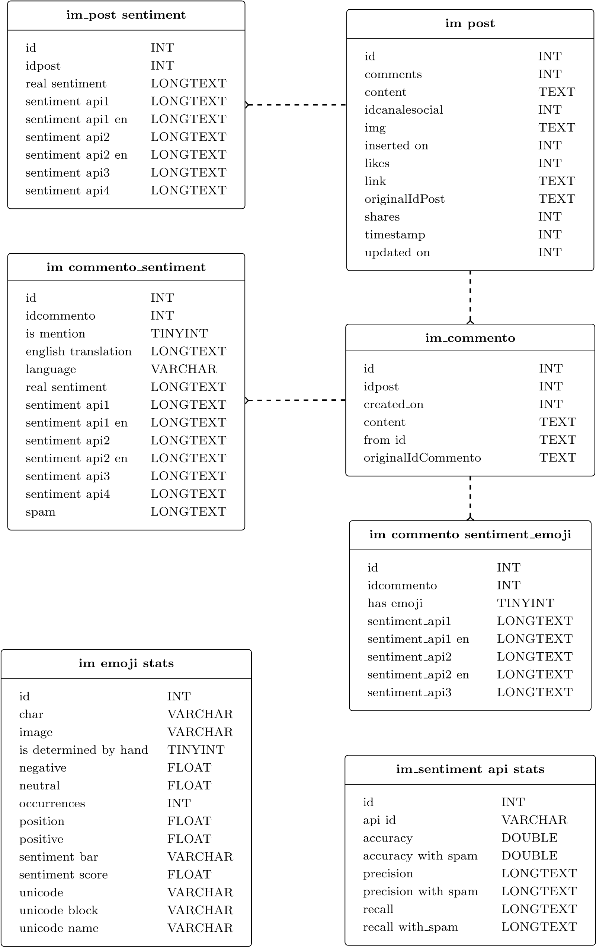

Figure 4.2: Database schema

*4. Framework*

As previously stated, we have extended and built our framework on top of a preexisting relational MySQL database schema which came with a set of specifications that were adopted and applied to sentiment db. Using a version of MySQL greater or equal to 5.5.3 was a hard constraint because in that release MySQL introduced support for uft8mb4 encoding. As opposed to uft8’s three bytes per character maximum, uft8mb4 uses a maximum of four bytes per character making it fully compatible with uft8 and, most importantly, able to correctly encode and store emojis. It is worth mentioning that only two data tables that were a part of the original database were used in analysis and those are im commento and im post.

For the sake of completeness, following tables contain details and field descriptions of used data tables.

###### im post

|  |  |  |
| --- | --- | --- |
| **id** | INT | PRIMARY KEY |
| comments | INT | number of comments the post has |
| content | TEXT | post’s content |
| idcanalesocial | INT | FORGEIN KEY to im canalesocial:  field links to the post’s social media account |
| img | TEXT | url to post’s accompanying photo |
| inserted on | INT | timestamp when the record was inserted |
| likes | INT | number of likes the post has |
| link | TEXT | url to the post on a social media site |
| originalIdPost | TEXT | identifier used on its social media site |
| shares | INT | number of shares the post has |
| timestamp | INT | timestamp when the post was created |
| updated on | INT | timestamp when the record was updated |

Table 4.1: Overview of im post database table

###### im commento

|  |  |  |
| --- | --- | --- |
| **id** | INT | PRIMARY KEY |
| idpost | INT | FORGEIN KEY to im post:  field links to the comment’s post |
| created on | INT | timestamp when the comment was created |
| content | TEXT | comment’s content |
| from id | TEXT | commentator’s id |
| originalIdCommento | TEXT | identifier used on its social media site |

Table 4.2: Overview of im commento database table

As mentioned, emojis play a big role in determining sentiment of a comment. Since none of the APIs took them into account, we used sentiment scores from *Emoji Sentiment Ranking*[4] published as a part of a sentiment analysis study[3], and imported them into the database table im emoji stats whose details are shown in Table 4.4. However, not all emojis or emoticons that occurred in our data set were included in the study (e.g. :) :D ). Which means they had to be manually inserted in the db. Their sentiment scores were determined by finding a similarly defined emoji and making the assumption that they had the same, or at least similar, sentiment. For example, green book’s () sentiment score was used in place for the missing blue book emoji (). An example of missing inserted emojis and their similar counterparts can be found in Table 4.3



|  |  |  |  |
| --- | --- | --- | --- |
| **Inserted icon** | **Similar icon** | **Sentiment score** | **Unicode name** |
|  |  | 0.491 | Blue book |
|  |  | 0.72 | Slightly smiling face |
|  |  | 0.491 | Dark sunglasses |
| :-) :) =) |  | 0.657 | Smiley face |
| :* |  | 0.71 | Kiss face |
| *<*3 |  | 0.657 | Heart |

Table 4.3: Example of inserted emojis into im emoji stats database table

###### im emoji stats

|  |  |  |
| --- | --- | --- |
| **id** | INT | PRIMARY KEY |
| char | VARCHAR | emoji characers |
| is determined by hand | TINYINT | boolean variable that denotes if emoji or emoticons were added by hand or used stats from the study *Emoji Sentiment Ranking* |
| negative | FLOAT | how negative is the emoji ∈ [0*,*1] |
| neutral | FLOAT | how neutral is the emoji ∈ [0*,*1] |
| occurrences | INT | number of occurrences of the emoji in all comments in our dataset |
| positive | FLOAT | how positive is the emoji ∈ [0*,*1] |
| sentiment score | FLOAT | overall sentiment score ∈ [−1*,*1] |
| unicode | VARCHAR | unicode codepoint of the emoji |
| unicode block | VARCHAR | general category an emoji falls into |
| unicode name | VARCHAR | descriptive name of the emoji |

Table 4.4: Overview of im emoji stats database table

*4. Framework*

To keep Tables 4.6, 4.5, 4.6 and 4.7 concise we’ve bundled descriptions of all sentimen api columns together. Each of those columns contain sentiment predictions of a specific API used. The (*column,API*) mappings can be found in table below.

|  |  |  |
| --- | --- | --- |
| **Database column** | **API** | **Used language** |
| sentiment api1 | Vivekn API | original language |
| sentiment api1 en | Vivekn API | english translation |
| sentiment api2 | Text-processing API | original language |
| sentiment api2 en | Text-processing API | english translation |
| sentiment api3 | Indico API | english translation |
| sentiment api4 | IndicoHq API | english translation |

Also, the columns in subsequent tables for which the data type is set to LONGTEXTdefault to a JSON string. Storing multi-value JSON strings might seem to go against the First Normal Form (1NF) rule which asserts that every column should hold a single value. However, MySQL 5.7. has introduced support for JSON. And one of its features is normalization of JSON documents prior to inserting [4]. Even though we opted for a version without JSON support, we’ve decided to code for future compatibility in order to avoid database bloat caused by an exaggerated number of columns. This way instead of having multiple columns for each (*API,language*) configuration, we have only one.

###### im post sentiment

|  |  |  |
| --- | --- | --- |
| **id** | INT | PRIMARY KEY |
| idpost | INT | FORGEIN KEY to im post:  the field points to post’s id |
| real sentiment | LONGTEXT | aggregation over post’s comments of: real sentiment data |
| sentiment api1, sentiment api1 en, sentiment api2, sentiment api2 en, sentiment api3, sentiment api4 | LONGTEXT | aggregation over post’s comments of: API’s sentiment predictions in original (English) language. All sentiment api columns default to:  {  "sentiment_stats": {  "positive": 9,  "negative": 2,  "neutral": 38,  "total": 49  },  "sentiment_label": "neutral"  "total_comments": 49,  } |

Table 4.5: Overview of im post sentiment database table

**im commento sentiment / im commento sentiment emoji**

|  |  |  |
| --- | --- | --- |
| **id** | INT | PRIMARY KEY |
| idcommento | INT | FORGEIN KEY to im comment:  the field points to comment’s id |
| is mention | TINYINT | boolean variable that denotes if there was a mention of a user in the comment (e.q @Anna) |
| english translation | LONGTEXT | Google Translate API’s English translation of the content |
| language | VARCHAR | Google Translate API’s prediction of content’s original language |
| real sentiment | LONGTEXT | manually determined sentiment |
| sentiment api1, sentiment api1 en, sentiment api2, sentiment api2 en, sentiment api3, sentiment api4 | LONGTEXT | API’s sentiment prediction of content in original (English) language.  All sentiment api columns default to:  {  "sentiment_label": "", "sentiment_stats": {  "positive": 0,  "negative": 0  "neutral" : 0  }  } |
| spam | LONGTEXT | manually determined whether or not the content is spam defaults to:  {  "type": "",  "is_spam": false  } |

Table 4.6: Overview of im commento sentiment and im commento sentiment emoji database table

**im**

**sentiment**

**api**

**stats**

|  |  |  |
| --- | --- | --- |
| **id** | INT | PRIMARY KEY |
| api id | VARCHAR | String identifying API and comment content version used. For example:  sentiment_api1, sentiment_api1_en, sentiment_api1_emoji, sentiment_api1_en_emoji, sentiment_api2 ... |
| accuracy | DOUBLE | Accuracy of the API excluding comments marked as spam |
| accuracy with spam | DOUBLE | Accuracy of the API including comments marked as spam |
| precision | LONGTEXT | Precision per sentiment label of the API excluding comments marked as spam |
| precision with spam | LONGTEXT | Precision per sentiment label of the API including comments marked as spam |
| recall | LONGTEXT | Recall per sentiment label of the API excluding comments marked as spam |
| recall with spam | LONGTEXT | Recall per sentiment label of the API including comments marked as spam Example of recall and precision column values:  {  "positive": 0.5965,  "negative": 0.3946,  "neutral": 0.4578  } |

Table 4.7: Overview of im sentiment api stats database table

*4.2. Implementation*

##### 4.2.2 Sentiment analysis APIs

Four different APIs were chosen to be tried and evaluated against each other. They were chosen on the grounds of them being free and easily programmatically accessible regardless of the programming language used. Thus making it feasible for us to invoke them from our framework. Each of the APIs is called by making either a HTTP or HTTPS post request with a specific payload. The responses vary but all are parsed and stored in the format like the one shown in Listing 3.1.

###### Vivekn API

**Author:** Vivek Narayanan

**Web url:** http://sentiment.vivekn.com/docs/api/

**Database columns:** sentiment api1 and sentiment api1 en

As described on the API’s website, the tool works by examining individual words and short sequences of words which then compares against a probability model. The probability model was built on a prelabeled test set of IMDb movie reviews and it is based on the *Fast and accurate sentiment classification using an enhanced Naive Bayes model* study [5]. The API is invoked via an HTTP post request with a txt payload that supplies comment’s content. The request, response and the form in which the response was stored in sentiment db is presented in Table 4.8.

|  |  |
| --- | --- |
| **request** | {  "txt": "Beautiful!"  } |
| **response** | {  "result": {  "sentiment": "Positive",  "confidence" : 72.422451  }  } |
| **stored** | {  "sentiment_label": "positive", "sentiment_stats": {  "positive": 0.724,  "negative": 0,  "neutral" : 0  }  } |

Table 4.8: Request and response payload to Vivekn API

###### Text-processing API

**Web url:** http://text-processing.com/docs/sentiment.html

**Database columns:** sentiment api2 and sentiment api2 en

This API is also trained on movie reviews but uses two binary classifiers. More specifically, it uses hierarchical classification by combining a subjectivity classifier and a polarity classifier. First, the subjectivity classifier determines whether the text is objective or subjective. If the text is objective, then it is classified as neutral. Otherwise the polarity classifier is used to determine if the text is positive or negative. More details on the implementation can be found in articles [6], [7], [8] and [9]. However, the two classifier model introduces a caveat. Sentiment probabilities of positive and negative labels always sum up to one, while the neutral label is standalone and dominates the result if its probability is greater than 0.5. The response, request and the stored JSON strings are shown in Table 4.9.

|  |  |  |
| --- | --- | --- |
| **request** | {  } | "text": "Beautiful!" |
| **response** | {  } | "label": "neg",  "probability": {  "neutral": 0.38637609994709854,  "neg": 0.68846305481785608,  "pos": 0.31153694518214375  } |
| **stored** | {  } | "sentiment_label": "negative", "sentiment_stats": {  "positive": 0.311,  "negative": 0.688,  "neutral" : 0.386  } |

Table 4.9: Request and response payload to Text-processing API

*4.2. Implementation*

###### Indico API

**Web url:** https://indico.io/docs#sentiment

**Web url (hq):** https://indico.io/docs#sentiment hq

**Database columns:** sentiment api3 and sentiment api4 (hq)

Even though we used all APIs as black boxes, the Indico API was treated as such even more so because implementation details weren’t readily available on its website. It was also the only API that required registration in order to obtain an authorization key to access it. It did, however, provide two different endpoints, a regular sentiment analysis and a high quality (hq) version. API’s response is a number between 0 and 1. This number represents the likelihood that the analyzed text is positive. Meaning, values greater than 0.5 indicate positive sentiment, while values below that threshold indicate a negative sentiment. Since we were operating within a three label domain, a script was made to label all likelihoods ∈ [*a,b*] as neutral to see how the accuracy (and other metrics) would change. The response, request and the stored JSON are listed in Table 4.10.

|  |  |  |
| --- | --- | --- |
| **request** | {  } | "data": "Beautiful!",  "api_key": 68d30f...,  "language": "english" |
| **response** | {  } | "results": 0.3468102081511113 |
| **stored** | {  } | "sentiment_label": "positive", "sentiment_stats": {  "positive": 0.654,  "negative": 0.346,  "neutral" : 0  } |

Table 4.10: Request and response payload of Indico and IndicoHq API endpoints

25

##### 4.2.3 Sentiment analysis scripts

The logic of all workflows described in Chapter 3 is implemented as a collection of python scripts. If we were to take the top down approach as we did in Chapter 3, we can start mapping specific nodes in workflow flowcharts to single scripts.

Predicting sentiment, determining real sentiment and performance evaluation parts of Figure 3.1 are realized via *automated sentiment analysis.py*, *update real sentiment and spam.py* and *evaluate api performance.py*, respectively.

###### API evaluation script

The *evaluate api performance.py* script can be invoked via the command line and it stores the results in im sentiment api stats database table. It accepts the following optional arguments:

**–help -h** shows all available arguments and exits

**–api** *<***name***>* specifies which API ∈ {sentiment api1, sentiment api1 en, sentiment api2, sentiment api2 en, sentiment api3, sentiment api4} to evaluate. If not specified, script evaluates all APIs

**–metric** *<***name***>* specifies which metric ∈ {precision, accuracy, recall} to calculate. If not specified, all are calculated

**–spam** calculates performance metric(s) for specified API(s) taking into account all comments regardless weather or non they were tagged as spam

**–no-spam** calculates performance metric(s) for specified API(s) taking into account only the comments not tagged as spam. If neither no-spam nor spam arguments were specified, the metrics are calculated for both cases

**–emoji** calculates performance metric(s) for specified API(s) of sentiment statistics from im commento sentiment emoji table

**–no-emoji** calculates performance metric(s) for specified API(s) of sentiment statistics from im commento sentiment table If neither no-emoji nor emoji arguments were specified, the metrics are calculated for both

###### Usage and sample output

$ python evaluate_api_performance.py --metric accuracy

------------------------------------------------------

Calculations for api: sentiment_api1_emoji with spam

Real sentiment distribution {

"positive": "43.51%",

"neutral": "45.61%",

"negative": "10.88%"

}

*4.2. Implementation*

True positives:

{’positive’: 1205, ’neutral’: 2167, ’negative’: 177} False negatives:

{’positive’: 1439, ’neutral’: 605, ’negative’: 484} False positives:

{’positive’: 517, ’neutral’: 1694, ’negative’: 317}

Total sentiment predictions: 6077

Accuracy: 0.584000

- - - - - - - - - - - - - - - - - - - - - - - - - - -

Updating table im_sentiment_api_stats

Setting ‘accuracy_with_spam‘ = 0.584

Where ‘api_id‘ = ’sentiment_api1_emoji’

... 1 row affected

------------------------------------------------------

###### Script for determining real sentiment

The *update real sentiment and spam.py* script can be invoked via the command line and stores the results in im commento sentiment table. For each comment the script displays its content and prompts user for input to determine:

1. whether or not the comment is only a user tag (e.g @Anna)
2. whether or not the comment is spam and if so, to specify a type
3. comment sentiment

The script accepts the following optional arguments (if no arguments are specified script runs for all comments):

**–help -h** shows all available arguments and exits

**-idgt** *<***nb***>* runs for all comments that satisfy *id > nb*

**-idlt** *<***nb***>* runs for all comments that satisfy *id < nb*

**-ideq** *<***nb nb***>* runs for the the space separated list of comment ids

###### Usage and sample output

$ python update_real_sentiment_and_spam.py -ideq 6 7

--------------------------------------------------

Comment_id: 6

Content: Bellissime!

English translation: Beautiful!

27

* - - - - - - - - - - - - - - - - - - - - - - - -

Is this comment ONLY a mention? (y/n): n

Updating table im_commento_sentiment

Setting ‘is_mention‘ = 0

Where idcommento = 6

... 1 row affected

* - - - - - - - - - - - - - - - - - - - - - - - -

Is this comment spam? (y/n): n

Updating table im_commento_sentiment

Setting ‘spam‘ = ’{"type": "", "is_spam": false}’

Where idcommento = 6

... 1 row affected

* - - - - - - - - - - - - - - - - - - - - - - - -

Determine the real_sentiment: pos/neg/neu/mix? pos

Updating table im_commento_sentiment

Setting ‘real_sentiment‘ = ’{

"sentiment_label": "positive",

"sentiment_stats": {

"positive": 1,

"negative": 0,

"neutral": 0

}}’

Where idcommento = 6

... 1 row affected

--------------------------------------------------

###### Automated sentiment analysis

The sentiment prediction workflow in Figure 3.2 is implemented by *automated sentiment analysis.py* script. Each part of the workflow is implemented by an independent script that exports its functionality via s single function. Additionally, all of them are also standalone scripts and can be run via the command line. The following

tablecontainsabreakdownofscriptsusedby

*automated*

*sentiment*

*analysis.py*

.

translate

comments.py

The script:

1.

gets comment’s original content from

im

commento

2.

calls Google Translate API with comment’s content

|  |  |
| --- | --- |
|  | 3. stores the translation and detected language in im commento sentiment data table  **Command line arguments:** -h, -ideq, -idlt, -idlt |
| predict comment sentiment.py | Depending on the command line arguments or function parameters provided, the script:   1. gets comment’s original content from im commento 2. gets comment’s English translation content from im commento sentiment 3. calls one (or all) APIs for sentiment analysis 4. stores the new sentiment prediction in im commento sentiment emoji table   **Command line arguments:** -h, -ideq, -idlt, -idlt, -api, – original-language |
| update sentiment prediction with emojis.py | If comment contains emojis, the script:   1. gets sentiment stats from im commento sentiment table 2. adds the sentiment score from im emoji stats for each emoji 3. normalizes stats so the likelihoods of positive, negative and neutral labels add up to 1 4. stores the new sentiment prediction in im commento sentiment emoji table   **Command line arguments:** -h, -ideq, -idlt, -idlt, -api |
| update post sentiment stats.py | Depending on the command line arguments or function parameters provided, the script:   1. gets sentiment stats from im commento sentiment or im commento sentiment emoji table for all post’s comments 2. count per API how many positive, negative and neutral comments the post has 3. normalizes stats so the likelihoods of positive, negative and neutral labels add up to 1 4. stores the results of this aggregation in im post sentiment stats table   **Command line arguments:** -h, -ideq, -idlt, -idlt,  -api column |

###### Usage and sample output

$ python predict_comment_sentiment.py -api ViveknAPI -ideq 6

--------------------------------------------------

Comment_id: 6 Content: Bellissime!

Translation: Beautiful!

Updating table im_commento_sentiment

Setting ‘sentiment_api1_en‘ = ’{

"sentiment_stats": {

"sentiment_label": "positive",

"positive": 0.724,

"negative": 0,

"neutral": 0,

}

}’

Where idcommento = 6

... 1 row affected

--------------------------------------------------

##### 4.2.4 Web server

Our web server is hosted on a Digital Ocean server, accessible via the domain name *sentiment-analysis.ml*. The server is set up as a Linux Ubuntu virtual machine with 512MB of RAM memory and 20GB of disk space.

It essentially runs two web applications build with Django 1.9+, the python web framework. Both web applications conform to Django’s Model Template View pattern, from now on refereed to as MTV. The patter is similar to the better known Model View Controller pattern. They are essentially the same paradigm, only what Django refers to as Template maps to the MVC’s View, and Django’s View corresponds to MVC’s Controller. All the slight variations between the two paradigms have been documented in depth in *Mastering Django: Core*[10]. In short, Django’s Model represents the underlying, logical structure of data and the relationships between the data. The Template is the presentation layer. More specifically, it’s a collection of HTML pages. Finally, the View contains all business logic code. Views are usually positioned between models and templates and are used to communicate between them.

One of the web applications is a more traditional website used to aid development by having results accessible in a presentable and aggregated manner. The other is a REST API with a graphical user interface based on Django’s REST API which provides a handy way of interacting with the data. Other than being able to access

*4.2. Implementation*

the API and modify the data via a browser by going to *sentiment-analysis.ml/api/*, it can also be accessed from the command line, using tools like curl. For e.g.

# Get a list of posts:

$ curl -u username:password \

http://sentiment-analysis.ml/api/posts/?page=2 \

-H ’Accept: application/json; indent=2’

# Get a specific post’s details:

$ curl -u username:password \

http://sentiment-analysis.ml/api/posts/<id>/ \

-H ’Accept: application/json; indent=2’

# Get a list of comments:

$ curl -u username:password \

http://sentiment-analysis.ml/api/comments/?page=1 \

-H ’Accept: application/json; indent=2’

# Get a specific comment’s details:

$ curl -u username:password \

http://sentiment-analysis.ml/api/comments/<id>/ \

-H ’Accept: application/json; indent=2’

# Modify comment’s real sentiment:

$ curl -X PUT \

-u username:password \ http://sentiment-analysis.ml/api/comments/<id>/ \

-d ’{"real_sentiment":{"sentiment_label": "positive"}}’ \

-H "Content-Type: application/json" \

-H ’Accept: application/json; indent=2’

#### 4.3 User interface

The User Interface, later in the text UI, has been split into two sections. One more suitable for a regular user, which contains stylized components representing our results. The other section consists of JSON REST API user interface, where data and our results are represented in JSON format. We will give more comprehensive explanation of each of them in the following two sections.

##### 4.3.1 Web Application UI

In this section we have shown data from the data dump such as list of posts with their related comments. Post details are shown in a separate fragment of the page shown in the figure below. Fragment consist of content of the post, post engagement and links towards Facebook post and JSON REST API web page containing same information in JSON format.

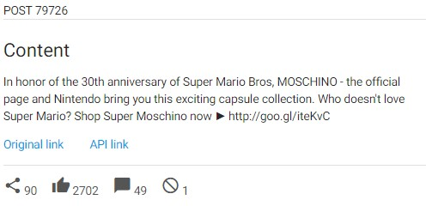

Figure 4.3: Post Details Fragment

User is able to choose a specific post from the list of posts located in the left side of the page. Choosing a post, the fragment containing post details reloads with new data and under it lists all comments related to it. The representation of a list item of the comment list is represented in next figure. Comment fragment has original language comment content and the English translated version, under the content we outlined sentiment analysis results of most accurate API compared with real sentiment score. User can see detailed representation of sentiment scores for each API separately. In case of comments being marked as spam, there is an indicator clearly pointing it out.

*4.3. User interface*

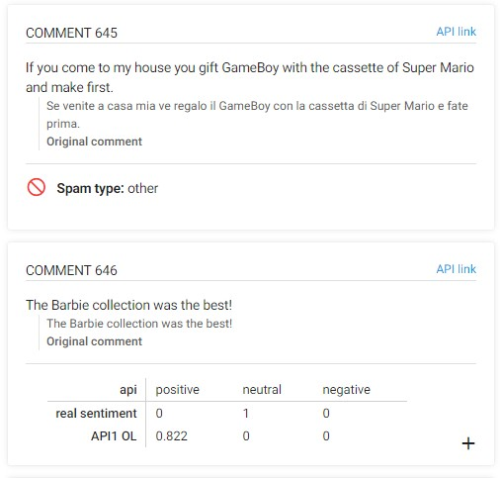

Figure 4.4: Comment Fragment

Keeping in mind that the most preferred way of representing data is though visualization, we have decided to show sentiment scores though pie charts. Fragment that contains the chart is located on the right side of the web page. The chart fragment contains two pie charts, one representing statistics related to real sentiment score and second representing statistics related to sentiment score of chosen API as shown in the figure 4.5. User is able to choose between different APIs in order to visually compare them with real sentiment scores.

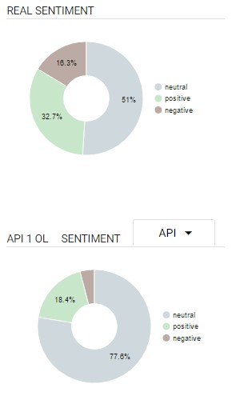

Figure 4.5: Chart representation of sentiment score

Navigating to Stats tab, we show how we have calculated the accuracy of APIs, list how many samples we have and list percentage of negative, positive and neutral real sentiment comments. This webpage gives opportunity to the user to see tabular representation of statistical results of each API with or without emojis, API with data translated in English and results taking into consideration the spam filters.

Such tabular view has been enclosed below this paragraph.

*4.3. User interface*

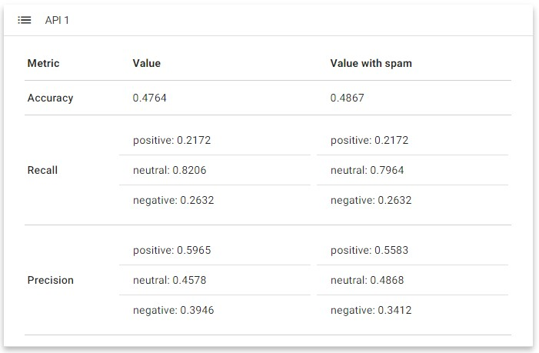

Figure 4.6: Tabular representation of statistical results for an API

##### 4.3.2 JSON REST API UI

This section represents the data in JSON form using Django REST Framework. The used framework has brought us to having a browsable Web API in few steps. Following official documentation we were able to define all the relations between our entities and easily retrieve needed data. One of few views we are able to reach is shown on the figure below.

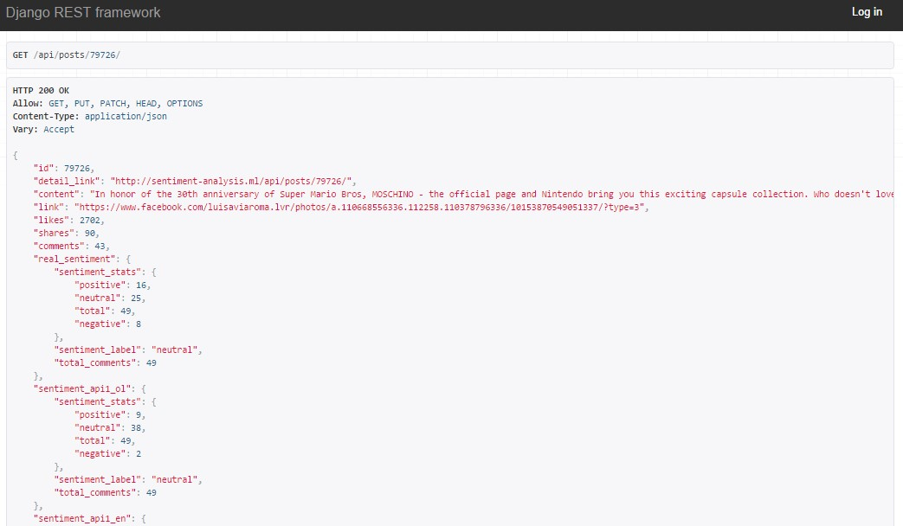

Figure 4.7: JSON representation

**Chapter 5**

**Results of APIs comparison**

In this chapter we show how the developed framework allowed us to compare the performance of selected APIs (the ones described in Section 4.2.2). And in turn, the comparison allowed us to assess the validity of the framework. This chapter also aims to indicate how the framework can easily be extended for assessment of other, additional APIs.

### 5.1 Experimental setting

In our dataset we had a total of 6088 comments out of which 6.02% were labeled as spam and 24.7% contained at least one emoji or emoticon. As far as determining real sentiment by hand goes: 10.89% of the comments were labeled as negative, 45.49% as neutral and 43.62% as positive. It is obvious there is a bias in our data towards neutral and positive sentiments. This may be due to a small sample size, but more likely it is because people tend to leave more positive feedbacks rather than negative.

To evaluate APIs three metrics were used: accuracy, precision and recall. They were calculated by running the *evaluate api performance.py* script. For the sake of completeness, below are the formulas used to calculate those 3 metrics.

Accuracy is the simplest of all metrics as it is just the fraction of correctly classified comment sentiments.

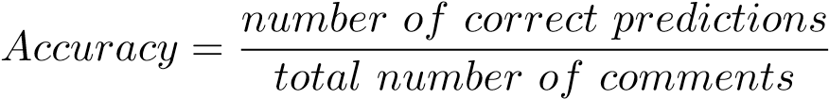

Precision and recall, on the other hand, are a bit more complex to understand and are calculated separately for each sentiment label ∈ {*positive,negative,neutral*}. While their calculation is quite straightforward in a binary classification problem, it gets a bit more challenging to intuit the logic in a multi-class problem. Primarily because the concepts used such as positive are traditionally explained by a single confusion matrix and in this case they would have to be explained by three- one for each of the classification labels. To minimize redundancy, a confusion matrix for the positive sentiment class is shown in Table 5.1.

|  |  |  |  |
| --- | --- | --- | --- |
| HHHHHHtrueHH  predicted | positive | negative | neutral |
| positive | TP | FP | FP |
| negative | FN | - | - |
| neutral | FN | - | - |

H

Table 5.1: Confusion matrix for the positive sentiment label

The following definitions are used in the case of calculating *TP,FP,FN* values for the positive sentiment label (the same rationale can be extended for the negative and neutral labels:

**True Positive (TP):** number of correctly predicted labels. More specifically, number of correctly identified pairs {*real, predicted*}: {*positive, positive*}

**False Positive (FP):** number of times the API predicted the label in question when it shouldn’t have. More specifically, it would be the total number of misclassified pairs {*real, predicted*}: {*negative, positive*} and {*neutral, positive*}

**False negative (FN):** number of times the API didn’t predict the label when it should have. More specifically, it would be the total number of misclassified pairs {*real, predicted*}: {*positive, negative*} and {*positive, neutral*}

With this information we can proceed in defining the other two metrics used.

Recall is the proportion of true {*positive, negative, neutral*} comments that were actually predicted correctly. In other words, out of all truly {*positive, negative, neutral*} examples, what fraction did the classifier manage to pick up?

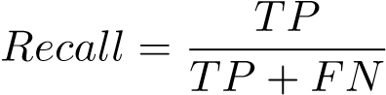

Precision tells us what proportion of all the labels that were predicted as {*positive, negative, neutral*} truly are {*positive, negative, neutral*}. In other words, out of all the examples the classifier labeled as {*positive, negative, neutral*} what fraction was correct?

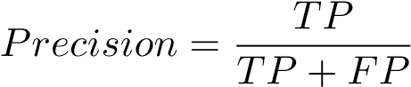

### 5.2 Results and discussion

The calculated metrics discussed in Section 5.1 can be found in their entirety in Tables 5.2, 5.3 and 5.4. However, the data in a table format is a bit dense and presents a challenge to anyone who wants to gain valuable insights from it. To help with the visualization data were also presented in form of a few bar charts. The first two showing accuracy across all APIs, and the rest displaying precision and recall for Text-processing API.

If we take a closer look at the accuracy charts we can immediately see that predictions which used English translations had higher accuracy over the predictions made using content in original language. In fact, the accuracy was improved by 11.34% on average across all APIs used.

Taking comments marked as spam out of the equation does improve overall accuracy but by a very small margin of 1%. One of the reasons for such small improvement could be that the fraction of spam data was relatively low (6.02%) and hence couldn’t have a big impact on the metric.

However, the biggest impact on accuracy is gained by the usage of English translations containing emojis. Accuracy of predicted sentiments of translated comments improved on average 19.39% when emojis were taken into account. What is even more interesting to note is the fact that emoji sensitive sentiment predictions of comments in original language outperform English emoji-less predictions by 9% w.r.t to accuracy. Both of these numbers prove that we were correct in assuming that emojis were a very important factor when it comes to determining content sentiment.

All APIs had improved their accuracy to be above 60% with the interventions our framework introduced. The interventions being translating comments and taking emojis into account. And out of all Text-processing API predicted sentiment of comments 74% ofthe time. That is great result indeed because when it comes to determining sentiment even humans can’t do it 100% accurately. Indeed, human accuracy tends to be around 80%, meaning people tend to agree on sentiment only around 80% of the time. This shines a different light on the results [11].

Looking at the recall and precision bar charts of the Text-processing API we can see how both metrics improved with using English translations and emojis. But the improvement is much more prominent with respect to recall and the positive label. Which means that the classifier managed to pick up a larger number of positive comments then originally. On the other hand, it seems the API struggled with identifying the ones labeled negative. As we can see from the charts, at best, Textprocessing API picked up on 48% of negative comments; meaning it misclassified more than half as either positive or neutral. But we would need more data labeled negative (more than 10.89% at least) in order for us to confidently conclude the API didn’t perform well with respect to comments having negative sentiment.

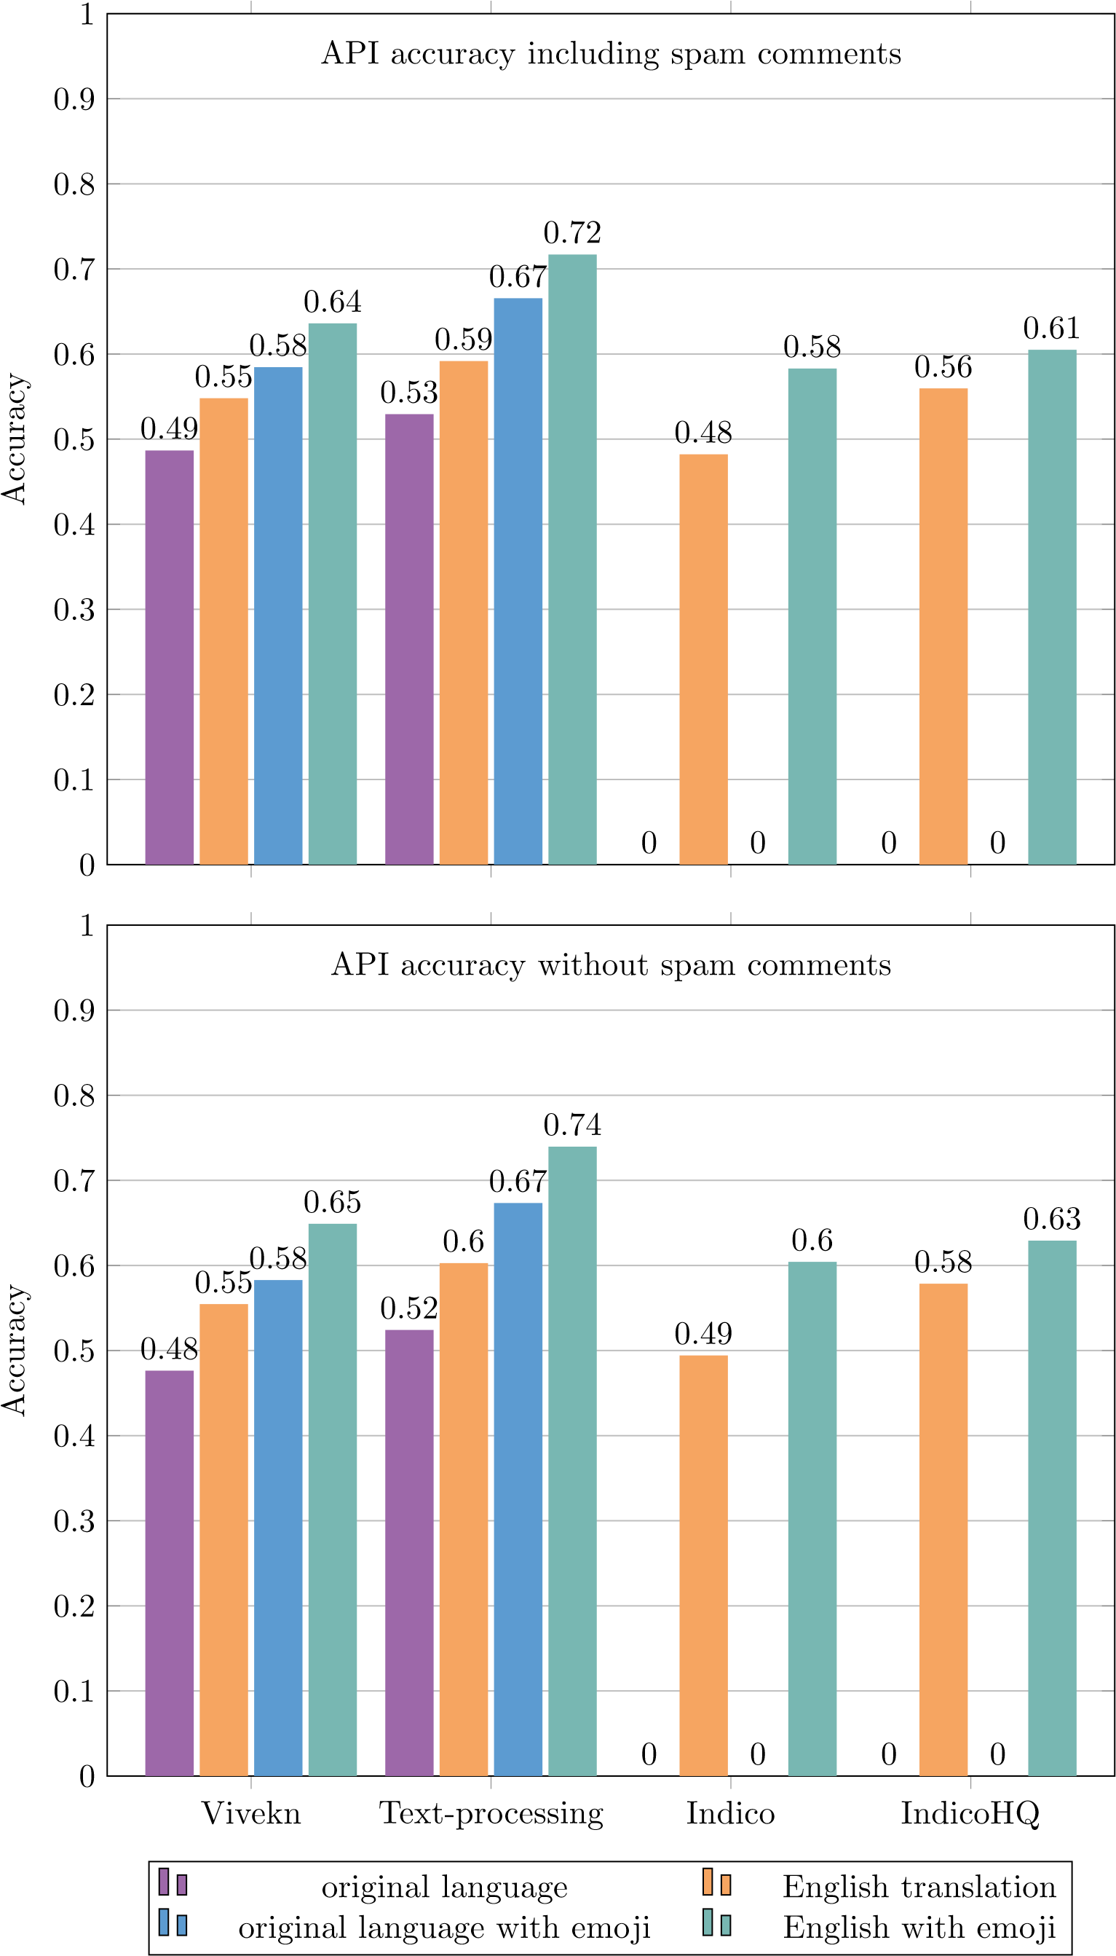

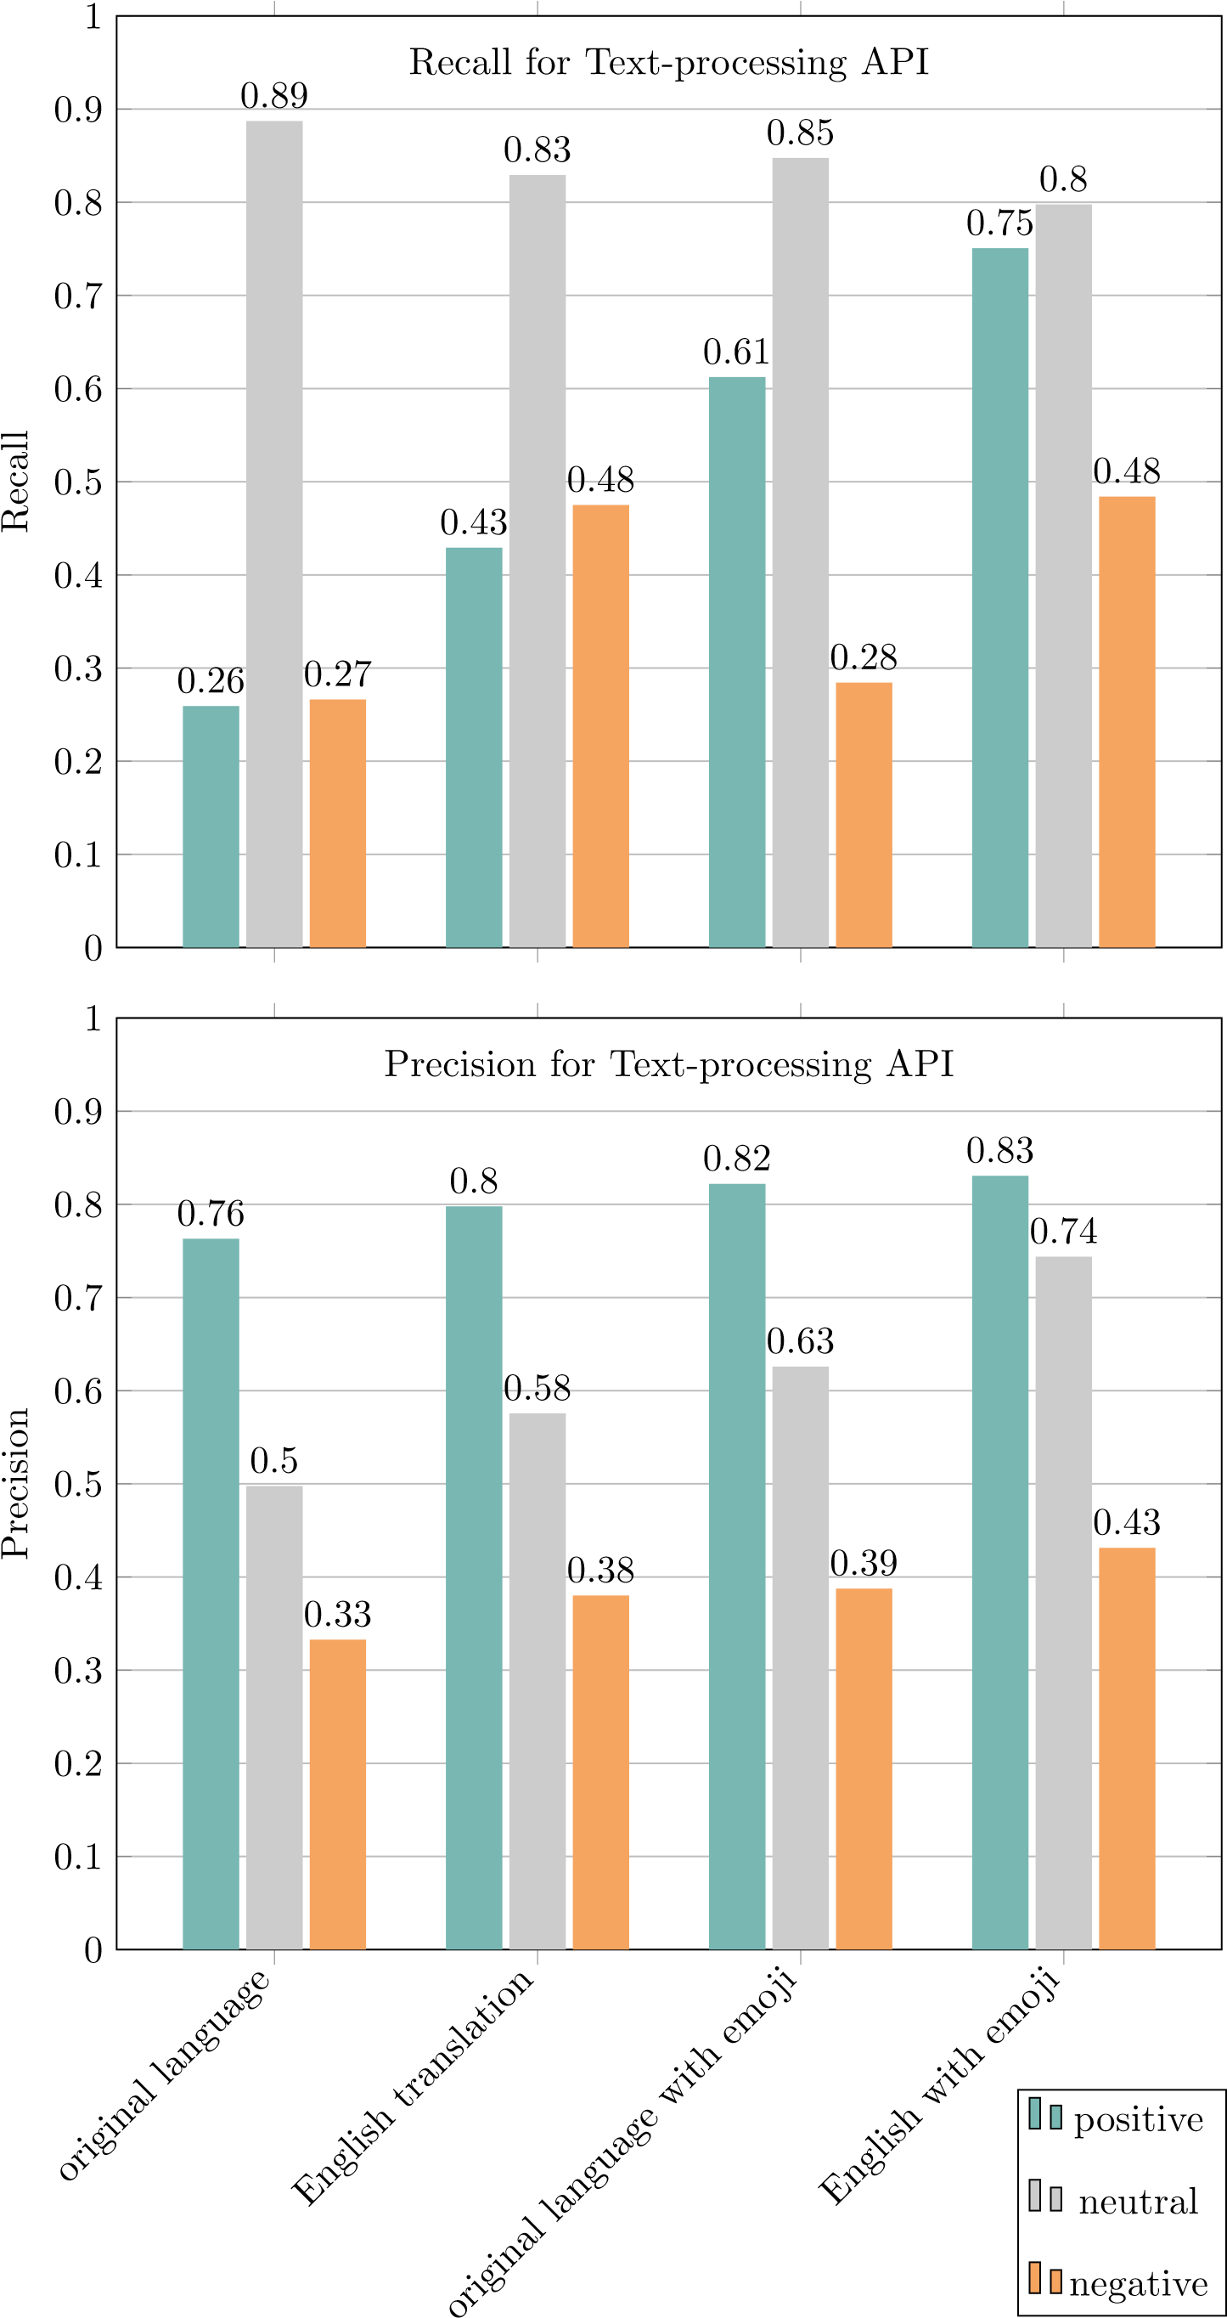

|  |  |  |
| --- | --- | --- |
| **API configuration** | **Precision without spam** | **Precision with spam comments** |
| Vivekn original language (ol) | ”positive”: 0.5965, ”neutral”: 0.4578,  ”negative”: 0.3946 | ”positive”: 0.5583, ”neutral”: 0.4868,  ”negative”: 0.3412 |
| Vivekn (en) | ”positive”: 0.6706, ”neutral”: 0.529,  ”negative”: 0.4522 | ”positive”: 0.6323, ”neutral”: 0.5498,  ”negative”: 0.3946 |
| Vivekn (ol) with emoji | ”positive”: 0.7351, ”neutral”: 0.5342,  ”negative”: 0.4126 | ”positive”: 0.7001, ”neutral”: 0.562,  ”negative”: 0.3583 |
| Vivekn (en) with emoji | ”positive”: 0.7482, ”neutral”: 0.6215,  ”negative”: 0.4793 | ”positive”: 0.7138, ”neutral”: 0.6406,  ”negative”: 0.4178 |
| Text-processing (ol) | ”positive”: 0.7631, ”neutral”: 0.4977,  ”negative”: 0.3327 | ”positive”: 0.6964, ”neutral”: 0.5223,  ”negative”: 0.3019 |
| Text-processing (en) | ”positive”: 0.7978, ”neutral”: 0.5757,  ”negative”: 0.3801 | ”positive”: 0.7324, ”neutral”: 0.5934,  ”negative”: 0.3451 |
| Text-processing (ol) with emoji | ”positive”: 0.822, ”neutral”: 0.6259,  ”negative”: 0.3876 | ”positive”: 0.776, ”neutral”: 0.6471,  ”negative”: 0.3527 |
| Text-processing (en) with emoji | ”positive”: 0.8307, ”neutral”: 0.7438,  ”negative”: 0.4313 | ”positive”: 0.7801, ”neutral”: 0.7561,  ”negative”: 0.3912 |
| Indico (en) | ”positive”: 0.616, ”neutral”: 0.4829,  ”negative”: 0.2915 | ”positive”: 0.5841, ”neutral”: 0.5135,  ”negative”: 0.2704 |
| Indico (en) with emoji | ”positive”: 0.6756, ”neutral”: 0.7059,  ”negative”: 0.3318 | ”positive”: 0.6426, ”neutral”: 0.7284,  ”negative”: 0.308 |
| IndicoHQ (en) | ”positive”: 0.5839, ”neutral”: 0.5479,  ”negative”: 0.6193 | ”positive”: 0.5541, ”neutral”: 0.5738,  ”negative”: 0.5558 |
| IndicoHQ (en) with emoji | ”positive”: 0.61, ”neutral”: 0.7031,  ”negative”: 0.6161 | ”positive”: 0.5785, ”neutral”: 0.7224,  ”negative”: 0.5602 |

Table 5.2: Precision stats

|  |  |  |
| --- | --- | --- |
| **API configuration** | **Recall without spam comments** | **Recall with spam comments** |
| Vivekn original language (ol) | ”positive”: 0.2172, ”neutral”: 0.8206,  ”negative”: 0.2632 | ”positive”: 0.2172, ”neutral”: 0.7964,  ”negative”: 0.2632 |
| Vivekn (en) | ”positive”: 0.3683, ”neutral”: 0.7669,  ”negative”: 0.5295 | ”positive”: 0.3683, ”neutral”: 0.7247,  ”negative”: 0.5295 |
| Vivekn (ol) with emoji | ”positive”: 0.456, ”neutral”: 0.8093,  ”negative”: 0.2678 | ”positive”: 0.456, ”neutral”: 0.7824,  ”negative”: 0.2678 |
| Vivekn (en) with emoji | ”positive”: 0.5814, ”neutral”: 0.7573,  ”negative”: 0.5265 | ”positive”: 0.5814, ”neutral”: 0.7145,  ”negative”: 0.5265 |
| Text-processing (ol) | ”positive”: 0.2592, ”neutral”: 0.8872,  ”negative”: 0.2663 | ”positive”: 0.2592, ”neutral”: 0.8512,  ”negative”: 0.2663 |
| Text-processing (en) | ”positive”: 0.4292, ”neutral”: 0.8293,  ”negative”: 0.475 | ”positive”: 0.4292, ”neutral”: 0.7752,  ”negative”: 0.475 |
| Text-processing (ol) with emoji | ”positive”: 0.6124, ”neutral”: 0.8476,  ”negative”: 0.2844 | ”positive”: 0.6124, ”neutral”: 0.8078,  ”negative”: 0.2844 |
| Text-processing (en) with emoji | ”positive”: 0.7507, ”neutral”: 0.7977,  ”negative”: 0.4841 | ”positive”: 0.7507, ”neutral”: 0.7405,  ”negative”: 0.4841 |
| Indico (en) | ”positive”: 0.6007, ”neutral”: 0.336,  ”negative”: 0.643 | ”positive”: 0.6007, ”neutral”: 0.3302,  ”negative”: 0.643 |
| Indico (en) with emoji | ”positive”: 0.8553, ”neutral”: 0.3168,  ”negative”: 0.643 | ”positive”: 0.8553, ”neutral”: 0.3077,  ”negative”: 0.643 |
| IndicoHQ (en) | ”positive”: 0.7752, ”neutral”: 0.3451,  ”negative”: 0.6399 | ”positive”: 0.7752, ”neutral”: 0.3336,  ”negative”: 0.6399 |
| IndicoHQ (en) with emoji | ”positive”: 0.8995, ”neutral”: 0.3322,  ”negative”: 0.6263 | ”positive”: 0.8995, ”neutral”: 0.3176,  ”negative”: 0.6263 |

Table 5.3: Recall stats

|  |  |  |  |
| --- | --- | --- | --- |
| **API configuration** | **Accuracy out spam** | **with-** | **Accuracy with spam comments** |
| Vivekn original language (ol) | 0.4764 |  | 0.4867 |
| Vivekn (en) | 0.5546 |  | 0.5481 |
| Vivekn (ol) with emoji | 0.5828 |  | 0.5846 |
| Vivekn (en) with emoji | 0.649 |  | 0.636 |
| Text-processing (ol) | 0.5242 |  | 0.5294 |
| Text-processing (en) | 0.6028 |  | 0.5917 |
| Text-processing (ol) with emoji | 0.6734 |  | 0.6656 |
| Text-processing (en) with emoji | 0.7396 |  | 0.717 |
| Indico (en) | 0.4942 |  | 0.4822 |
| Indico (en) with emoji | 0.6042 |  | 0.583 |
| IndicoHQ (en) | 0.5786 |  | 0.5596 |
| IndicoHQ (en) with emoji | 0.6292 |  | 0.605 |

Table 5.4: Accuracy stats

**Chapter 6**

**Conclusion**

In this final chapter we will summarize all the reasons for involving in such project, as well as the main contributions of the same. After listing the results we will address possible future improvements.

Nowadays with emerging markets and information flow it has become a necessity to try to predict future trends. Thus, companies are processing information luring through Internet with hope they will make a right choice. Big role in company’s marketing strategy are social media channels, such as Facebook, Twitter or Instagram. Recognizing the potential use of customers input on the Web, companies have started gathering data related to their online advertisements. Logically, next step was to find a proper way of processing the data in order to discover certain correlations that could guide their production planning. One of recent methods for doing so is called sentiment analysis.

Our report consists of describing current trends in the field of sentiment analysis and how it is applied in business. Showing the reasons for using such method has brought us to the idea of investigating about available open source solutions. We have tried to make a comparison with some of sentiment analysis APIs on a given dataset which consists of Facebook comments related to a certain post about fashion industry products. The project itself consists of building a framework representing in a user-friendly way data that has been provided to us with obtained sentiment results of different APIs. We have made a comparison of each API on its original data and on data translated in English. Our statistical results have shown that APIs in general perform better when doing analysis of comments translated in English.

Another point where we have seen a potential improvement in our analysis was taking into consideration emojis or emoticons. Currently, emojis have been one of the easiest and most used way of communication. People have seen them as a fast, expressive enough version of typed text. Taking this into consideration we have investigated about finding a proper way to use power of emojis to improve our results. The most obvious solution was building a hash table of emoticons and their

*6. Conclusion*

related English translations (for example :) equals happy). The idea of defining a such hash table has brought us to Emoji Sentiment Ranking which contains needed sentiment score for most of emoticons present in our dataset. For the ones missing the score we have identified a similar items from the rank table and assigned the same sentiment score.

After obtaining sentiment scores from different APIs on the various versions of the given data we were able to make a comparison between them. We were also able to show how a particular API performs on original data, data translated to English language and also on data taking emoji sentiment score into consideration.

In addition to the aspects analyzed by this work, there are several other points that can be deepened to improve our approach. We report in the following the ones we believe are the most important:

### 6.1 Connecting to mining approaches – Applying clustering in sentiment analysis

One of newer ideas in area of sentiment analysis is using clustering algorithms in order to obtain better sentiment analysis results, as explained in Using Clustering and Sentiment Analysis on Twitter[12]. Let’s start with explaining what is clustering. Clustering is a method of splitting datasets into subsets of similar items based on the content of the items. In our case this would imply splitting different post sentences in the same ”basket” depending on the content, which would result in groups of sentences talking about a similar product feature (product aspect). Clustering is an unsupervised learning method, which means that items are split in separate groups only based on similarity value calculated by its features (in this case the content of the posts). Different from classification method, where a model is trained based on past data, clustering method is based mostly on choosing an appropriate similarity measure. Another difference is that as output of classification original dataset is labeled with a class attribute, when in case of clustering, output is subsets of items.

By applying clustering based sentiment analysis, we might obtain high accuracy results. The process would then be organized as follows :

1. Data gathering
2. Data cleaning
3. Computing the Term Frequency and Inverse Document Frequency
4. Applying K-means clustering algorithm
5. Sentiment Analysis Engine

*6.2. Spam detection*

After the data is gathered, it would be good to find an automatic data cleaning method to will remove all the outliers from the dataset. When obtaining relatively noisy free data we should perform TF-IDF in order to determine keywords in the content that could possibly represent a feature of an analyzed product. TF stands for Term Frequency, represents how many times a term occurs in a document. IDF stands for Inverse Document Frequency, and represents how common is a term in all documents. After determining the keywords, we can have an idea of how many clusters we should expect in our dataset. This could be an input to the K-means algorithm, thus K-means chooses k random points as initial centroids and assigns all other points to the nearest centroid. Next step of the algorithm is re-centering the current centering. The process repeats until the next iteration produces same result as the previous iteration. Output of clustering method is set of clusters, where each cluster contains similar sentences.

Output of the clustering step represents an input to the sentiment analysis engine. Each cluster is inserted in the engine to determine sentiment of people on a particular feature of the product. Applied to our problem domain, the steps would go like so: On each comment related to post, we would do data preprocessing, removing noisy data from the comment. Afterwards determining keywords in the comment related to the post. For example comment describing customers experience after using the product, such as a customer commenting on the fabric, quality, and color of the blouse. As input in K-mean we would have three aspects of product, in our case k would be 3. K-means would group all comment sentences related to each of the product features (quality, fabric and color). Afterwards, we apply the sentiment analysis on each cluster and obtain a sentiment value. This way we could calculate the overall sentiment value joining the cluster sentiment values, thus obtaining higher accuracy results.

Downsides of this approach:

1. Applying method on large scale data
2. Eliminating noisy data from social media content should usually involve human interaction
3. Weaknesses of K-means method

## 6.2 Spam detection

One of the future improvements could be finding a better method for spam detection in order to filter out noisy comments that could give us less accurate sentiment estimation. How could we differ spam from comments that are related to a post? Spam is an unwanted content appearing in the stream of comments. By unwanted content we assume content not related to the post or any other comments of the

*6. Conclusion*

post. For example, URLs leading to third party web pages used as advertisements or a person that is tagged without any other information about the post. It is in our favor to try to remove such content from the analysis set which could lead to better sentiment estimation.

We can look at spam detection as one of data preprocessing techniques. Currently we have used Akismet for spam detection; it is a web service for recognizing spam comments. To be able to estimate the effectiveness of Akismet service, we have determined manually if a comment is a spam or not. Having a small comment dataset it was not time consuming to manually analyze the comments. After the analysis we have calculated the accuracy of chosen spam detection method. Unfortunately, the results have shown that on our dataset Akismet was not so effective.

## 6.3 Out of the black box – Training a model

Our project has been based on testing different APIs for sentiment analysis and determining which of the used APIs has given the best results. Using APIs as they are could be imagined as using a tool without knowing what is actually going on inside it. This way we could not tune the algorithm to suit our problem domain. By going out of the box, we could build a model that would provide us with better sentiment analysis results.

Training a model can be seen as producing a function that applied on future data could give sentiment “class label”, in our case positive, negative or neutral value, with higher accuracy then the used APIs. The process of building a model consists of training a model on training set, validating the model and afterwards testing in on the test set.

# Bibliography

1. H. Tregear, “Cathay pacific case study: Using social data to inform a global business,” 2016.
2. J. Bort, “How starbucks and other companies use complex math algorithms to read your feelings online,” 2012.
3. P. Kralj Novak, J. Smailovi´c, B. Sluban, and I. Mozetiˇc, “Sentiment of emojis,” *PLoS ONE*, vol. 10, no. 12, p. e0144296, 2015.
4. O. Corporation, “Mysql json data type.”
5. V. Narayanan, I. Arora, and A. Bhatia, “Fast and accurate sentiment classification using an enhanced naive bayes model,” *CoRR*, vol. abs/1305.6143, 2013.
6. “Text classification for sentiment analysis - stopwords and collocations.” Available at [http://streamhacker.com/2010/05/24/text-classificationsentiment-analysis-stopwords-collocations/.](http://streamhacker.com/2010/05/24/text-classification-sentiment-analysis-stopwords-collocations/)
7. “Text classification for sentiment analysis - naive bayes classifier.” Available at [http://streamhacker.com/2010/05/10/text-classification-sentimentanalysis-naive-bayes-classifier/.](http://streamhacker.com/2010/05/10/text-classification-sentiment-analysis-naive-bayes-classifier/)
8. “Text classification for sentiment analysis - eliminate low information features.” Available at [http://streamhacker.com/2010/06/16/textclassification-sentiment-analysis-eliminate-low-informationfeatures/.](http://streamhacker.com/2010/06/16/text-classification-sentiment-analysis-eliminate-low-information-features/)
9. “Hierarchical classification.” Available at [http://streamhacker.com/2011/ 01/05/hierarchical-classification/.](http://streamhacker.com/2011/01/05/hierarchical-classification/)
10. A. Holovaty and J. Kaplan-Moss, “Mastering django: Core,” 2008.
11. “Expert analysis: Is sentiment analysis an 80% solution?.” Available at [http:](http://www.informationweek.com/software/information-management/expert-analysis-is-sentiment-analysis-an-80--solution/d/d-id/1087919?)

[//www.informationweek.com/software/information-management/expertanalysis-is-sentiment-analysis-an-80--solution/d/d-id/1087919?](http://www.informationweek.com/software/information-management/expert-analysis-is-sentiment-analysis-an-80--solution/d/d-id/1087919?)

*Bibliography*

1. M.-H. Wu, “Using clustering and sentiment analysis on twitter,” Master’s thesis, Faculty of The School of Engineering & Computing Sciences Texas A&M University-Corpus Christi Corpus Christi, TX, 2014.

# List of Figures

|  |  |
| --- | --- |
| 3.1 Sentiment analysis workflow . . . . . . . . . . . . . . . . . . . . . . . | 9 |
| 3.2 Sentiment prediction workflow . . . . . . . . . . . . . . . . . . . . . | 10 |
| 3.3 Determine real sentiment workflow . . . . . . . . . . . . . . . . . . . | 14 |
| 4.1 Sentiment analysis framework . . . . . . . . . . . . . . . . . . . . . . | 16 |
| 4.2 Database schema . . . . . . . . . . . . . . . . . . . . . . . . . . . . . | 17 |
| 4.3 Post Details Fragment . . . . . . . . . . . . . . . . . . . . . . . . . . | 32 |
| 4.4 Comment Fragment . . . . . . . . . . . . . . . . . . . . . . . . . . . | 33 |
| 4.5 Chart representation of sentiment score . . . . . . . . . . . . . . . . | 34 |
| 4.6 Tabular representation of statistical results for an API . . . . . . . . | 35 |
| 4.7 JSON representation . . . . . . . . . . . . . . . . . . . . . . . . . . . | 35 |

*List of Figures*

# List of Tables

|  |  |
| --- | --- |
| 4.1 Overview of im post database table . . . . . . . . . . . . . . . . . . | 18 |
| 4.2 Overview of im commento database table . . . . . . . . . . . . . . . . | 18 |
| 4.3 Example of inserted emojis into im emoji stats database table . . . | 19 |
| 4.4 Overview of im emoji stats database table . . . . . . . . . . . . . . | 19 |
| 4.5 Overview of im post sentiment database table . . . . . . . . . . . .  4.6 Overview of im commento sentiment and | 20 |
| im commento sentiment emoji database table . . . . . . . . . . . . | 21 |
| 4.7 Overview of im sentiment api stats database table . . . . . . . . . | 22 |
| 4.8 Request and response payload to Vivekn API . . . . . . . . . . . . . | 23 |
| 4.9 Request and response payload to Text-processing API . . . . . . . . | 24 |
| 4.10 Request and response payload of Indico and IndicoHq API endpoints | 25 |
| 5.1 Confusion matrix for the positive sentiment label . . . . . . . . . . | 38 |
| 5.2 Precision stats . . . . . . . . . . . . . . . . . . . . . . . . . . . . . . | 42 |
| 5.3 Recall stats . . . . . . . . . . . . . . . . . . . . . . . . . . . . . . . . | 43 |
| 5.4 Accuracy stats . . . . . . . . . . . . . . . . . . . . . . . . . . . . . . | 44 |

1. https://cloud.google.com/translate/v2/translating-text-with-rest
2. As mentioned in the previous section, there are two API’s for which we requested sentiment predictions in both, their original language and the English translation
3. http://kt.ijs.si/data/Emoji sentiment ranking
4. http://kt.ijs.si/data/Emoji sentiment ranking